Practical Robotics Projects with Arduino
(CSE 4571)

Lab Assignment No – 04

ULTRASONIC & IR SENSING

Submission Date: _______________

Branch: CSE Section:
Name | Registration No. | Signature

Department of Computer Science and Engineering
Institute of Technical Education and Research (Faculty of Engineering)
Siksha 'O' Anusandhan (Deemed to be University)
Bhubaneswar, Odisha-751030.

Aim:

Ultrasonic & IR Sensing – To Interface HC-SR04 and IR sensors with Arduino UNO for distance measurement and obstacle detection.

Objectives:
- To study the working principle of Ultrasonic (HC-SR04) and Infrared (IR) sensors.
- To interface HC-SR04 ultrasonic sensor with Arduino UNO for distance measurement and display the output values on I2C LCD.
- To interface IR sensor with Arduino Uno for obstacle detection using buzzer and LED.
- To validate distance measurement of HC-SR04 ultrasonic sensor using LEDs as indicators.

Pre-Lab Questionnaire:

A. Experiment-Specific
- What is the working principle of the HC-SR04 ultrasonic sensor for distance measurement?
- Mention the function of Trigger pin and Echo pin in the HC-SR04 sensor.
- Write the formula to calculate distance from the ultrasonic sensor using the speed of sound.
- What is the typical range of distance measured by an HC-SR04 ultrasonic sensor?
- What is the working principle of an Infrared (IR) sensor used for obstacle detection?
- Differentiate between active IR sensor and passive IR sensor with examples.
- State any two applications of ultrasonic sensors in real life.
- Why is it necessary to use pinMode() and digitalWrite() functions in Arduino while interfacing sensors?
- How does an IR sensor distinguish between the presence and absence of an obstacle?
- Mention one key advantage and one limitation of ultrasonic sensors compared to IR sensors?
Answers to Pre-Lab Questions

Components/Equipment Required:

Sl.  No. | Name of the  Component / Equipment | Specification | Quantity
1) | Arduino UNO R3 | 16MHz | 1
2) | Arduino UNO cable | USB Type A to Micro-B | 1
3) | Ultrasonic sensor HC-SR04 |  | 1
4) | IR sensor module | Obstacle detection | 1
5) | I2C LCD |  | 1
6) | Buzzer |  | 1
7) | Resistors (carbon type) | 220Ω / 330Ω | 2
8) | LED | Any colour of your choice | 8
9) | Breadboard | 840 Tie points | 1
10) | Jumper Wire | --------------------------- | As per requirement

Objective 2
To interface HC-SR04 ultrasonic sensor with Arduino UNO for distance measurement and display the output values on I2C LCD.

Circuit / Schematic Diagram
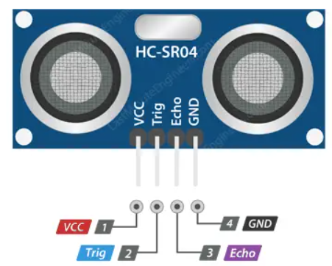
Figure 1: HC-SR04 Ultrasonic Sensor Pinout
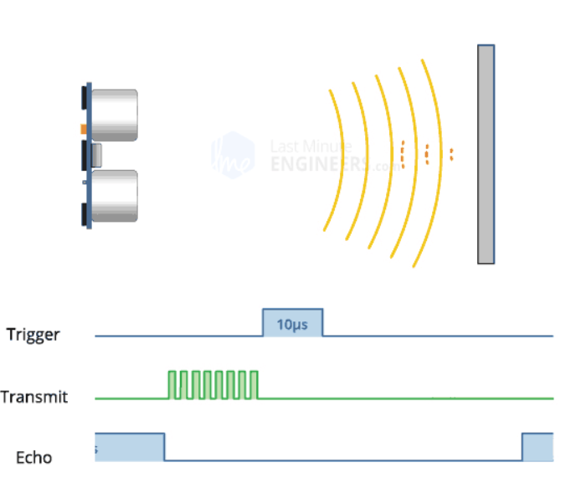

Figure 2: Work of HC-SR04

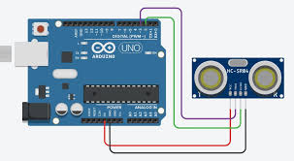
Figure 3: Ultrasonic Distance measurement circuit using HC-SR04 & Arduino Uno

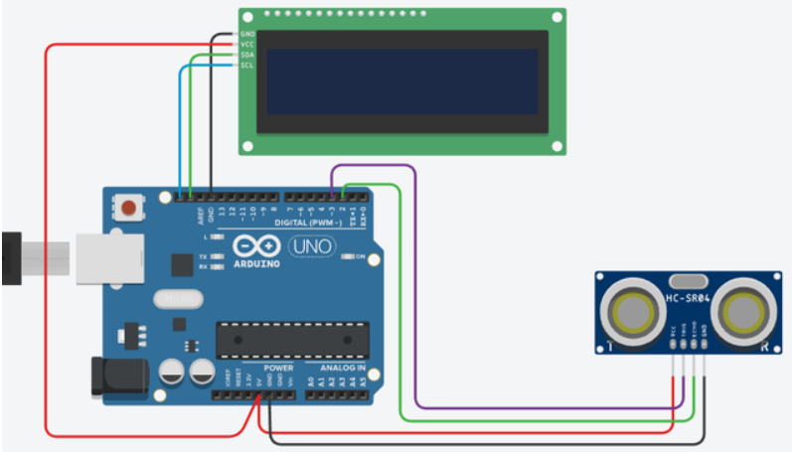
Figure 4: Ultrasonic Distance Measurement Output in LCD Display

Code
Write an Arduino program to interface HC-SR04 ultrasonic sensor with Arduino Uno for distance measurement and display the output value in I2C LCD.
#include <Wire.h>
#include <LiquidCrystal_I2C.h>
#define trigPin 9
#define echoPin 10
LiquidCrystal_I2C lcd(0x27, 16, 2); // I2C address 0x27, adjust if needed
void setup() {
lcd.init();
lcd.backlight();
pinMode(trigPin, OUTPUT);
pinMode(echoPin, INPUT);
lcd.setCursor(0, 0);
lcd.print("Distance Meter");
delay(1000);
lcd.clear();
}

void loop() {
long duration;
float distance;
// Send a 10µs pulse to trigger pin
digitalWrite(trigPin, LOW);
delayMicroseconds(2);
digitalWrite(trigPin, HIGH);
delayMicroseconds(10);
digitalWrite(trigPin, LOW);
// Read echo pin and calculate distance
duration = pulseIn(echoPin, HIGH);
distance = duration * 0.0343 / 2; // cm
// Handle out-of-range
if (distance > 400 || distance < 2) {
lcd.clear();
lcd.setCursor(0, 0);
lcd.print("Out of range");
} else {
lcd.clear();
lcd.setCursor(0, 0);
lcd.print("Distance:");
lcd.setCursor(0, 1);
lcd.print(distance, 1);
lcd.print(" cm");
}
delay(500); }


Observation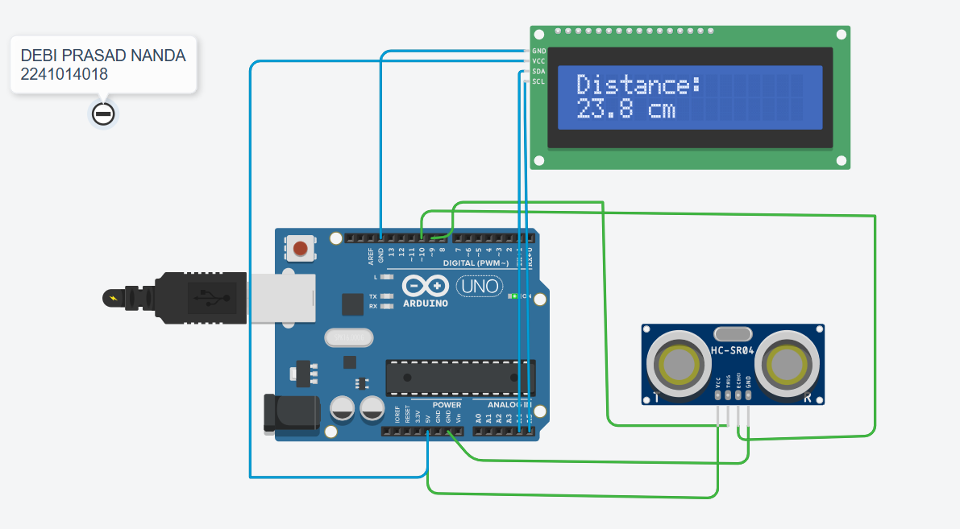

Figure 5: (Simuation based distance measurement using HC-SR04 ultrasonic sensor and output display in I2C LCD)

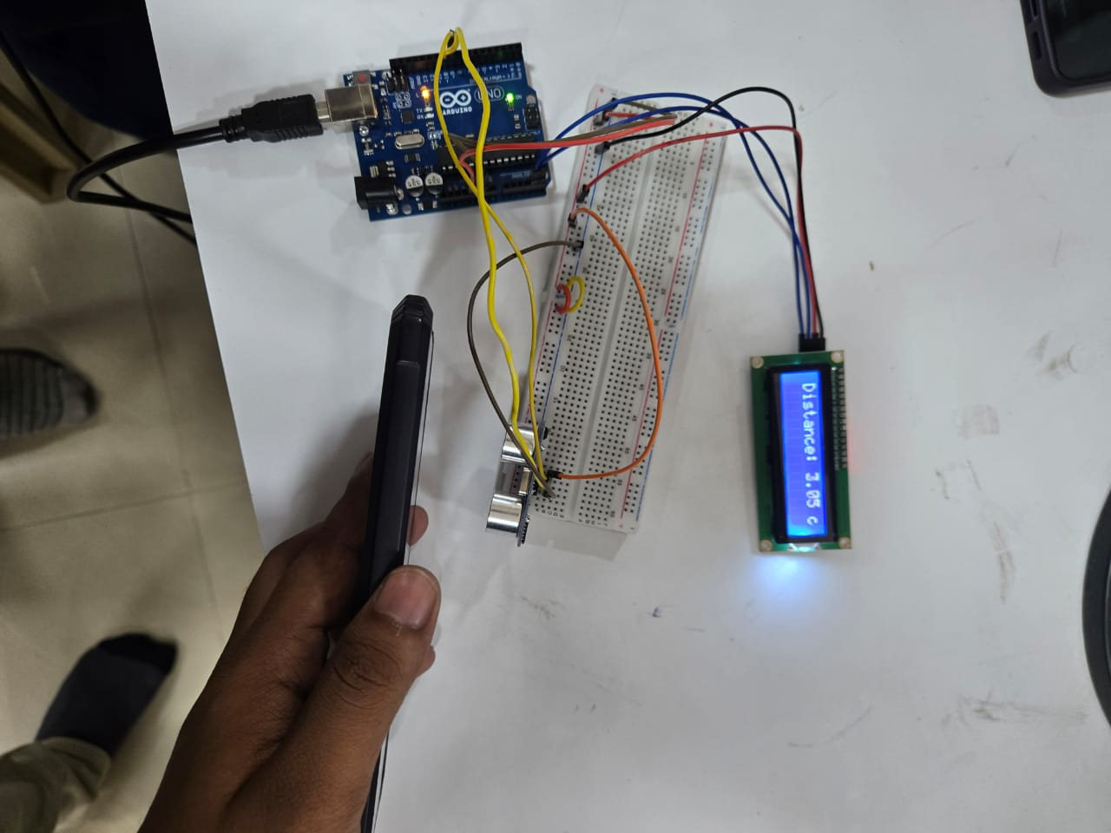

Figure 6: (Hardware Implementation based distance measurement using HC-SR04 ultrasonic sensor and output display in I2C LCD)

Objective 3
To interface IR sensor with Arduino Uno for obstacle detection using buzzer and LED.
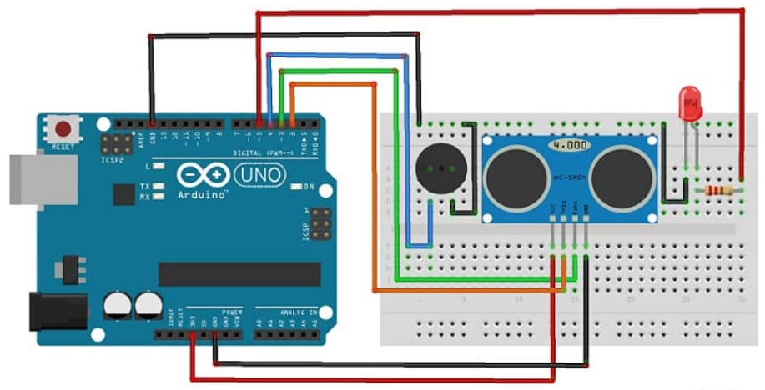
Figure 7: Interface IR sensor with Arduino UNO for obstacle detection

Code
Write an Arduino program to detect an obstacle in front, and turn ON the LED and buzzer.

#define TRIG_PIN 2
#define ECHO_PIN 3
#define LED_PIN 5
#define BUZZER_PIN 4

long duration;
int distance;

void setup() {
pinMode(TRIG_PIN, OUTPUT);
pinMode(ECHO_PIN, INPUT);
pinMode(LED_PIN, OUTPUT);
pinMode(BUZZER_PIN, OUTPUT);

Serial.begin(9600);
}

void loop() {
// Clear trigger
digitalWrite(TRIG_PIN, LOW);
delayMicroseconds(2);

// Send 10 µs pulse
digitalWrite(TRIG_PIN, HIGH);
delayMicroseconds(10);
digitalWrite(TRIG_PIN, LOW);

// Read echo
duration = pulseIn(ECHO_PIN, HIGH);

// Convert to cm
distance = duration * 0.034 / 2;

Serial.print("Duration: ");
Serial.print(duration);
Serial.print("\tDistance: ");
Serial.print(distance);
Serial.println(" cm");

// Buzzer and led activation when distance < 30
if (distance > 0 && distance <= 30) {
digitalWrite(LED_PIN, HIGH);
digitalWrite(BUZZER_PIN, HIGH);
} else {
digitalWrite(LED_PIN, LOW);
digitalWrite(BUZZER_PIN, LOW);
}

delay(500);
}

Observation

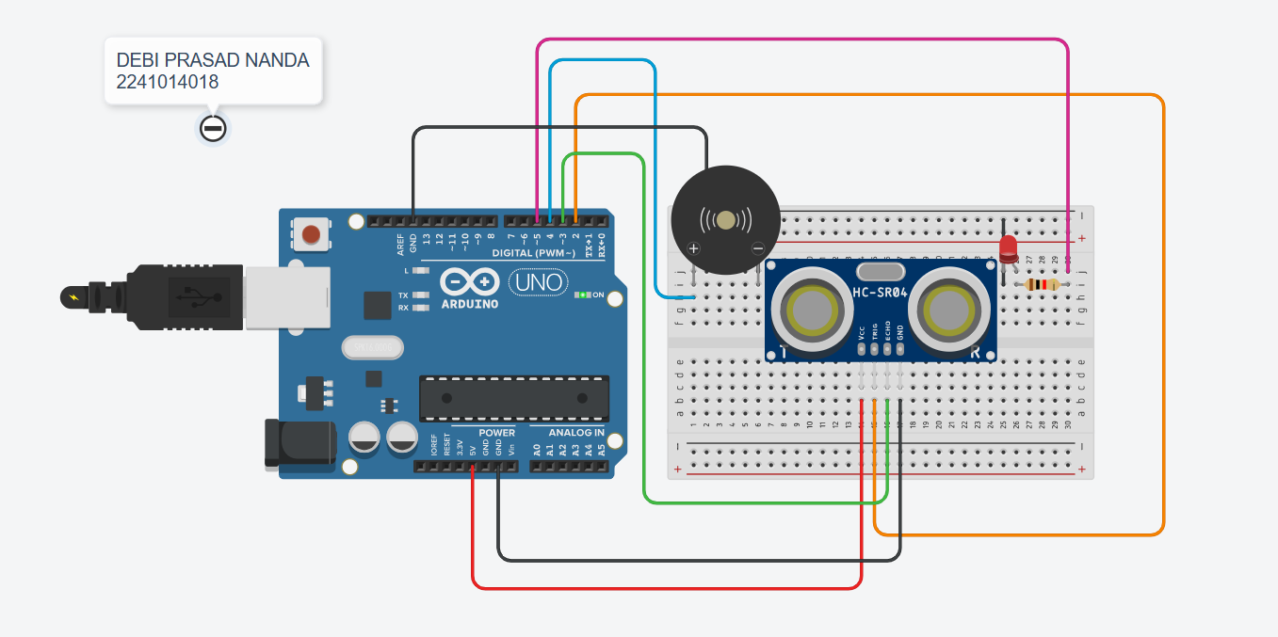

Figure 8: (Simulation based interfacing IR sensor and buzzer with Arduino UNO for obstacle detection)

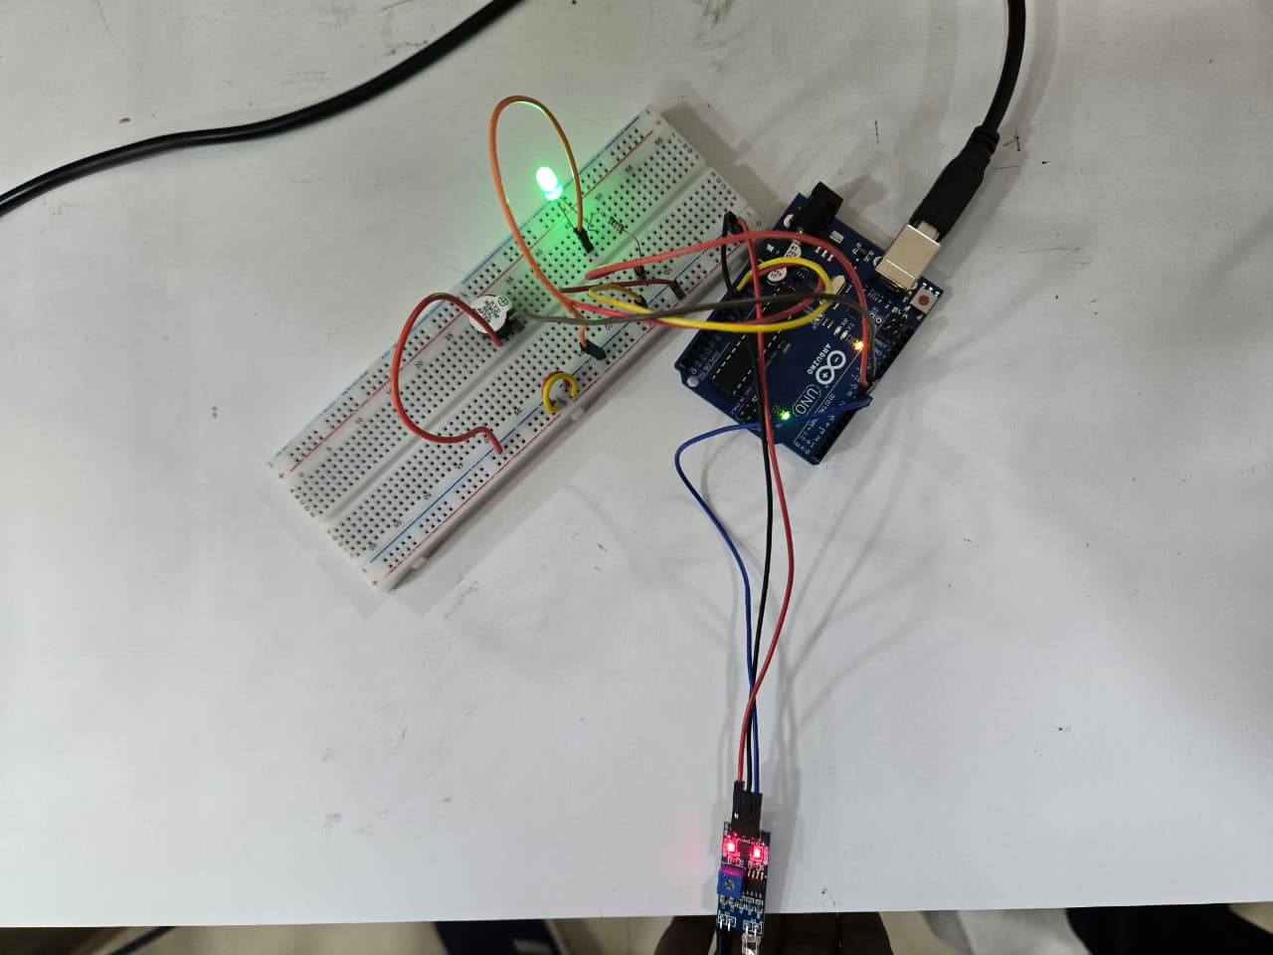

Figure 9: (Hardware Implementation of interfacing IR sensor and buzzer with Arduino UNO for obstacle detection)

Objective 4
To validate distance measurement of HC-SR04 ultrasonic sensor using LEDs as indicators.

Circuit / Schematic Diagram
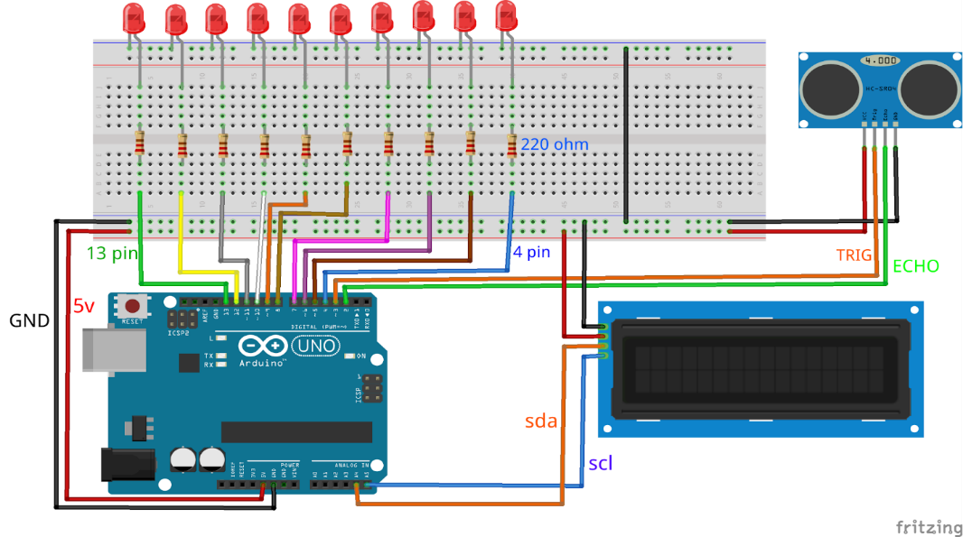
Figure 10: HC-SR04 + Arduino Uno +LCD+LED

Code

Write an Arduino program to integrate an ultrasonic sensor, an I2C LCD display, and LED indicators for real-time distance measurement and visualization.

#include <Wire.h>
#include <LiquidCrystal_I2C.h>

#define TRIG_PIN 3
#define ECHO_PIN 2

// LEDs from pins 4–13
int leds[] = {4, 5, 6, 7, 8, 9, 10, 11, 12, 13};
const int ledCount = 10;

// Initialize I2C LCD (usually address 0x27 or 0x3F)
LiquidCrystal_I2C lcd(0x27, 16, 2);

void setup() {
Serial.begin(9600);

pinMode(TRIG_PIN, OUTPUT);
pinMode(ECHO_PIN, INPUT);

// setup all LEDs
for (int i = 0; i < ledCount; i++) {
pinMode(leds[i], OUTPUT);
}

// initialize LCD
lcd.init();
lcd.backlight();
lcd.clear();
lcd.setCursor(0, 0);
lcd.print("Distance Sensor");
delay(1000);
}

void loop() {
long duration;
float distance;

// Trigger pulse
digitalWrite(TRIG_PIN, LOW);
delayMicroseconds(2);
digitalWrite(TRIG_PIN, HIGH);
delayMicroseconds(10);
digitalWrite(TRIG_PIN, LOW);

// Read echo pulse duration
duration = pulseIn(ECHO_PIN, HIGH, 30000);

// Convert to cm
distance = duration * 0.034 / 2;

// Safety check: ignore invalid readings
if (distance == 0 || distance > 400) {
lcd.clear();
lcd.setCursor(0, 0);
lcd.print("Out of range ");
Serial.println("Out of range");
} else {
// Print distance
lcd.clear();
lcd.setCursor(0, 0);
lcd.print("Distance:");
lcd.setCursor(10, 0);
lcd.print(distance, 1);
lcd.print("cm");

Serial.print("Distance: ");
Serial.print(distance);
Serial.println(" cm");
}

// LED visualization (equal gaps from 4 cm to 320 cm)
int numLEDs = map(distance, 4, 320, 0, ledCount);
numLEDs = constrain(numLEDs, 0, ledCount);

for (int i = 0; i < ledCount; i++) {
if (i < numLEDs) {
digitalWrite(leds[i], HIGH);
} else {
digitalWrite(leds[i], LOW);
}
}

delay(300);
}

Observation

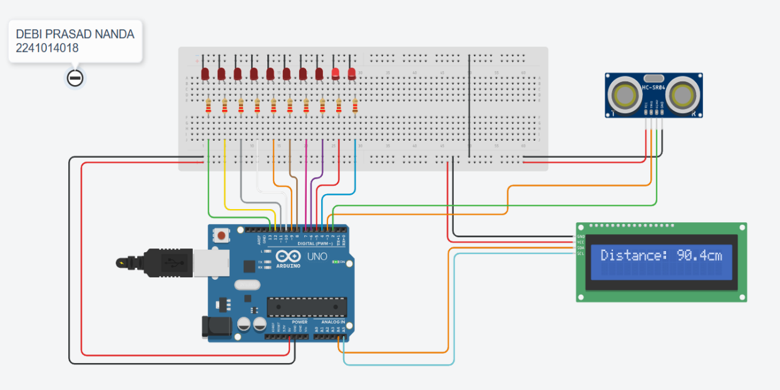

Figure 11: (Software Implementation of interfacing ultrasonic sensor, an I2C LCD display, and LED indicators)

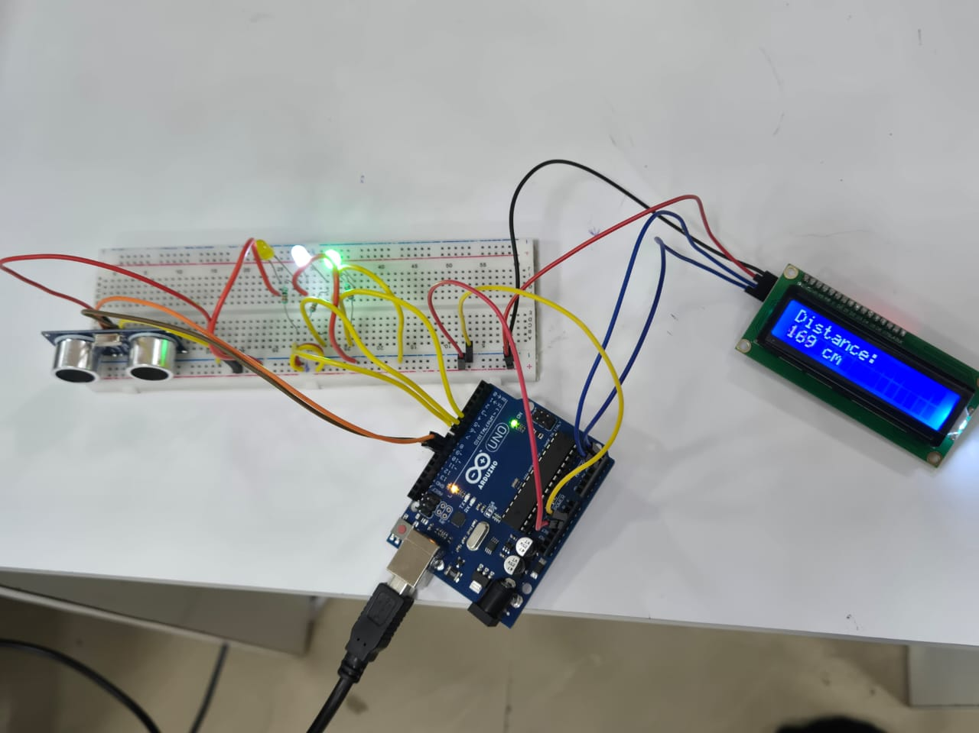

Figure 12: (Hardware Implementation of interfacing ultrasonic sensor, an I2C LCD display, and LED indicators)

Conclusion:

Precautions:

Post Experiment Questionnaire:

- Experiment-Specific (LED Blinking & LED Patterns)
- What happens if the Trigger pin of the HC-SR04 ultrasonic sensor is not given a proper 10 µs pulse?
- If the Echo pulse duration is measured as 2 ms, calculate the distance of the obstacle. (Speed of sound = 343 m/s)
- Why do ultrasonic sensors measure distance more accurately than IR sensors in outdoor conditions?
- What would be the effect of bright sunlight on the IR sensor’s performance?
- How can you modify the Arduino code to turn ON an LED when an obstacle is detected within 15 cm using the HC-SR04 sensor?
- If the ultrasonic sensor reads 200 cm, what should be the approximate Echo pulse duration?
- Why is it necessary to divide the total sound travel time by 2 in ultrasonic distance measurement?
- What logic output does the IR obstacle sensor provide when an object is detected?
- Mention one limitation of using only IR sensors for obstacle detection in mobile robots.
- Suggest a practical application where both ultrasonic and IR sensors are used together for better performance.?

(Signature of the Faculty) | (Signature of the Student)
 | Name:
Date: | Registration No.:
 | Branch:
 | Section

